ICON- Spotlight on Chamberlin Scholar Recipient: Rowan Casserly
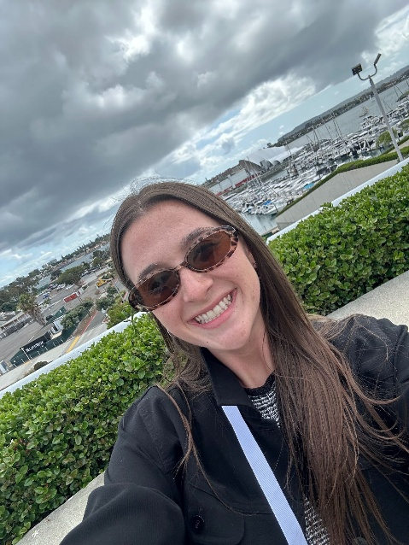
I was honored to be selected as one of the Association for Fundraising Professionals (AFP) Chamberlain Scholars for the 2026 AFP ICON conference in sunny San Diego, California. As my first-ever ICON experience, I would describe it as both inspiring and educational. The conference sessions were led by incredible thought leaders in the fundraising world, and I walked away with valuable insights on everything from introducing yourself to a donor to creating digital content that catches the attention of younger supporters.
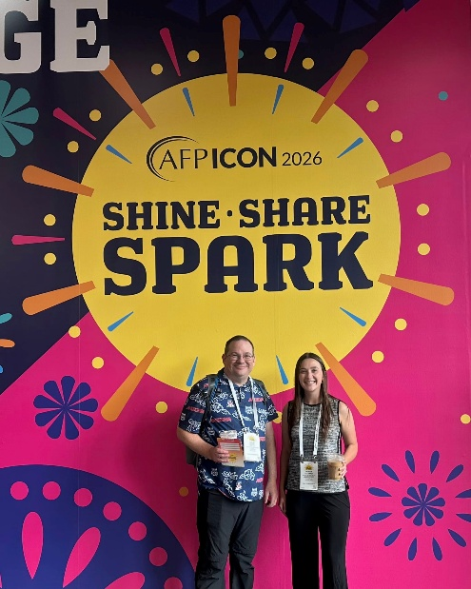
One session that especially stood out to me was led by local Southern Arizona AFP chapter member Frank Vasquez and his colleague, Niki Brown, who spoke about the importance of intentional language when communicating a nonprofit’s mission. He emphasized transparency, shared power, and accountability in messaging, all which are ideas that deeply resonate with me. Across all the sessions, one theme remained consistent: donors, staff, and board members are the driving force behind every mission. They are the people creating meaningful change in the philanthropic world, and they deserve to be valued as such.
While the educational sessions expanded my understanding of fundraising and nonprofit communications, the people I met were what truly made my ICON experience impactful. I had the opportunity to connect with incredible women from different areas of Arizona, all of whom were welcoming, encouraging, and genuinely interested in 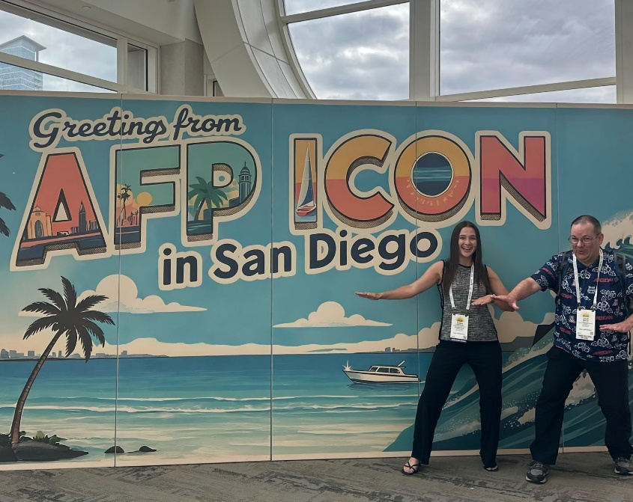
learning about my experiences. I had the pleasure of meeting AFP Greater Arizona chapter member Tatumn Zale, who was the 2026 Outstanding Young Professional of the Year. It was nice to know that there are young professionals like me in the field paving the way for the future of philanthropy.
I’m excited to bring this new knowledge and perspective back to the Cooper Center for Environmental Learning and apply it to the work we do every day. One of my biggest goals moving forward is to strengthen how we connect with current and future donors while creating a stewardship program that better reflects how deeply we value our supporters. Whether someone gives their time, resources, or advocacy, our community is the 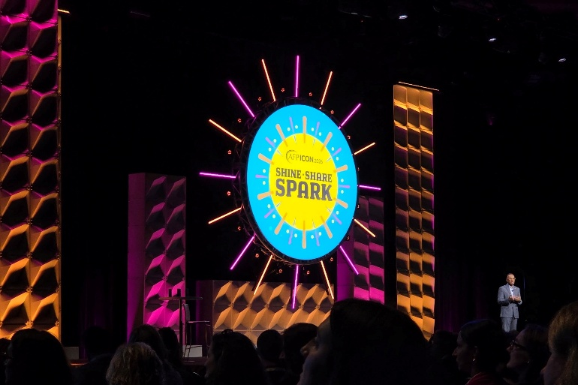
reason Camp Cooper continues to grow and serve students across Southern Arizona.
I am incredibly grateful to AFP for selecting me as a Chamberlain Scholar and to the Southern Arizona chapter for their continued support, encouragement, and investment in my professional growth. Throughout my time at ICON, I was reminded that the heart of philanthropy is rooted in human connection and kindness, something I witnessed regularly throughout this conference. This experience reinforced my passion for nonprofit work and philanthropy, and I look forward to continuing to grow within this field

